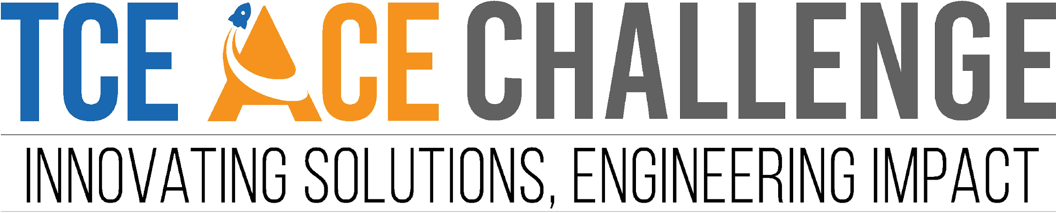

Idea & Abstract Submission

By

**“ D.A.N.E.J. Syndicate ”**

(NIT Agartala)

# Blockchain-Enabled Battery Swapping System

#### #COMPREHENSIVE OVERVIEW

Current charging infrastructure suffers from slow charging (at least 20 minutes).However, battery swapping is an alternative, but issues such as expiry date and battery history limit its large-scale implementation.

#### #PROBLEM SOLUTION/REPORT:

Proposing to integrate Blockchain Technology with EV Battery swapping .Blockchain will record each swap, expiry and battery lifecycle history on an immutable ledger. Smart algorithms will automate billing, access control, and energy credit distribution for efficient operations. This will eradicate the problem of slow charging.

#### #INNOVATION AND DISTINCTNESS OF THE SOLUTION/REPORT:

Current solution only focuses on swapping battery but there is no true system to make fair bills, introducing concept of **battery reserve score**, while swapping batteries customer have to pay only the energy charge bill but there will be also transaction (plus or minus) in battery reserve scores and this will be updated after every swap.

All the battery history will be recorded via **blockchain**. This technology can be used by an **app** which will be accessed only by users and the company(for batteries details) .

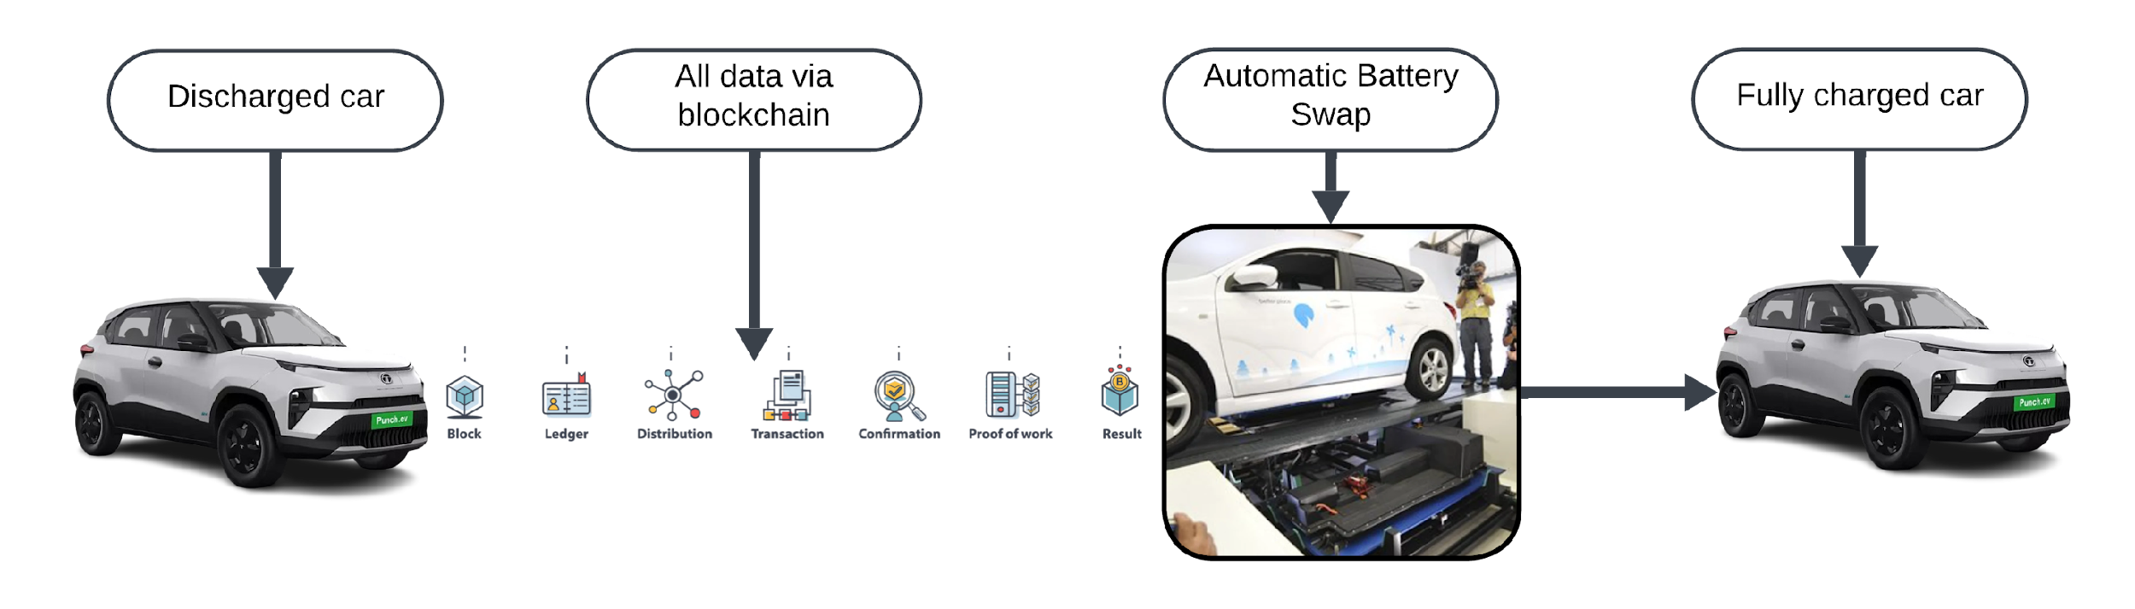Moreover, we can add **navigations** , UPI etc to make the app more **user friendly**.

### #TECHNICAL APPROACH

**Available Technologies Currently Utilized for the Use Cases :**

1. [NIO’s](https://www.nio.com/) proprietary systems can be enhanced by blockchain technology to improve scalability, trust, and cross-manufacturer compatibility.
2. Power Ledger’s energy trading systems can benefit from blockchain integration to enhance energy management and efficient battery swapping
3. [Sun Mobility](https://www.sunmobility.com/technology) can leverage blockchain for tamper-proof tracking of battery.

## #METHODOLOGY AND EXECUTION

* + **Research and Design:**

Analyse global battery specifications and blockchain frameworks to create a unified platform and develop blockchain-based smart contracts for battery transaction management.

## Prototypes and Testing:

Pilot blockchain-integrated swapping stations globally and testing for compatibility, security, and efficiency under diverse national conditions.

## Manufacturing and Deployment:

Collaborate with global EV manufacturers, battery suppliers for standardized battery designs and partnership with charging station operators.

## Marketing and Distribution:

Collaborate with governments, manufacturers, and energy providers worldwide to promote adoption through global campaigns emphasizing transparency, cost-efficiency, and environmental

sustainability.

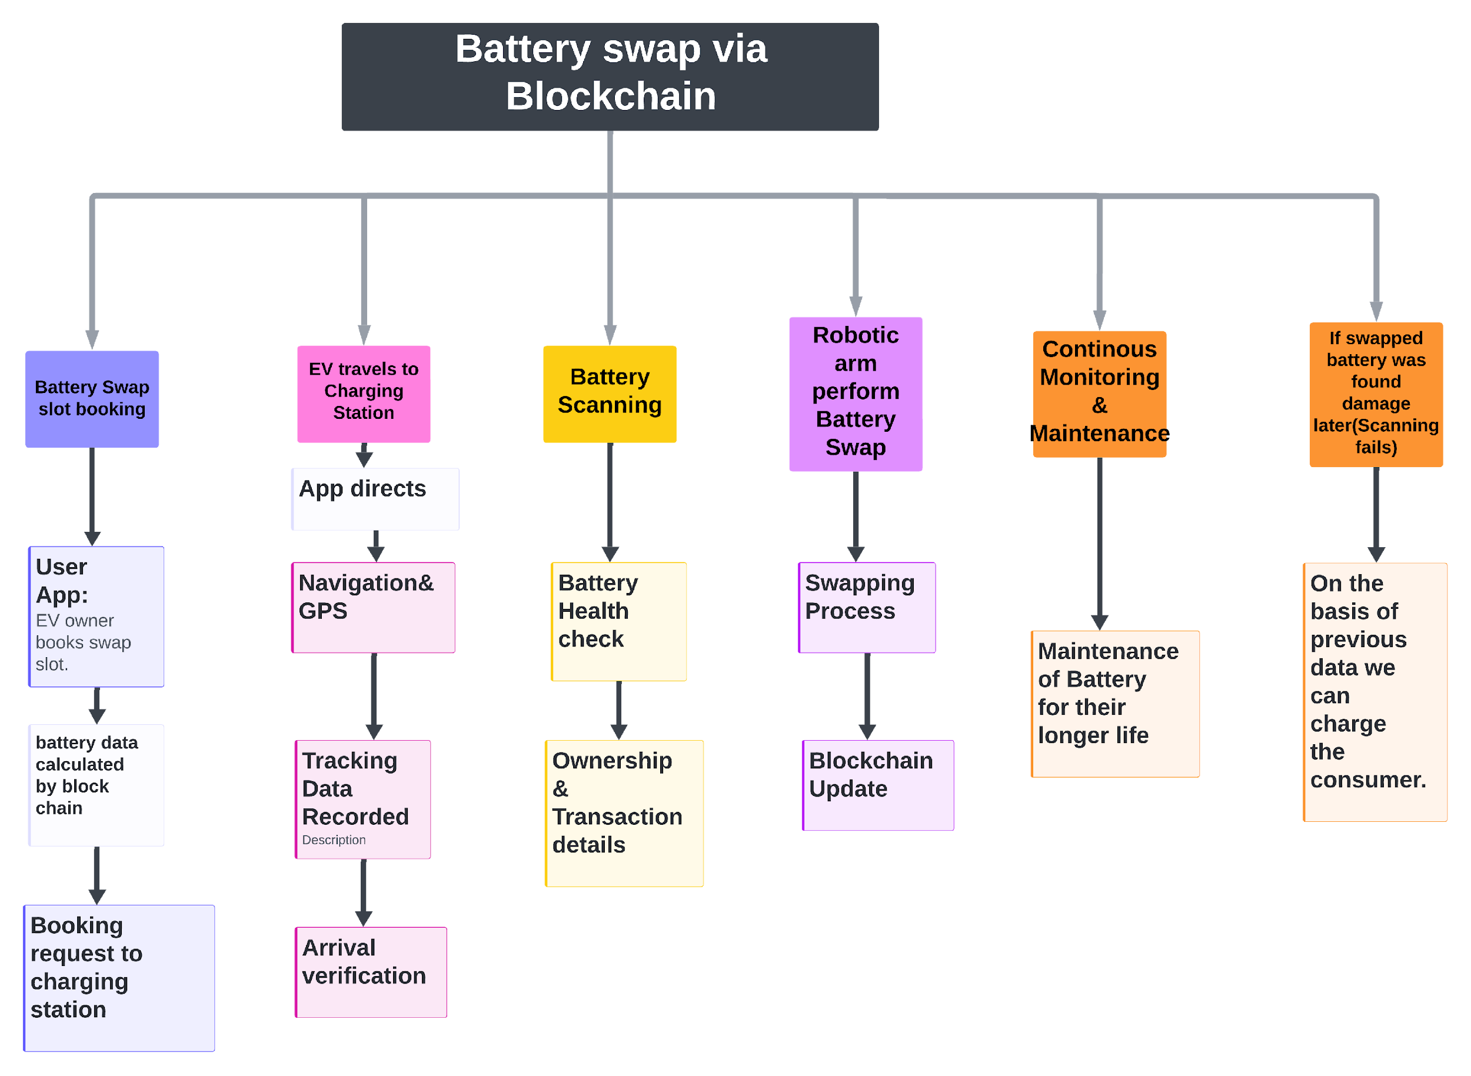

### #RESEARCH AND REFERENCES

* Blockchain for battery lifecycle management: <https://www.mdpi.com/2079-8954/11/6/299>
* Sun Mobility’ present technologies- <https://www.sunmobility.com/technology>
* Major challenges by charging infrastructure-

<https://codibly.com/evse/the-main-challenges-that-ev-charging-networks-face-today/>

* ISO 15118 and vehicle-grid standards: [https://www.iso.org](https://www.iso.org/)
* NIO present technologies- <https://www.nio.com/>

# Kinetic energy harvesting for urban charging station

#### #COMPREHENSIVE OVERVIEW

Generating energy while walking/vehicle passing and merging it with stored energy at charging station in urban areas.

#### #PROBLEM SOLUTION/REPORT:

Storing energy while vehicle passing and walking and utilise it in EV charging . Most of the electricity produced in India is from coal and we have to generate energy in all possible ways rather than only solar and wind energy.

#### #INNOVATION AND DISTINCTNESS OF THE SOLUTION/REPORT:

This problem is solved by using ‘Walk and harvest energy’ technique. This project aims to design and develop an energy harvester that uses [Pizoelectric materials](https://onlinelibrary.wiley.com/doi/full/10.1002/sstr.202100128#%3A~%3Atext%3DPiezoelectric%20energy%20harvester%20is%20the%2Cinto%20the%20usable%20electrical%20energy) coupled with an RLC circuit, to convert mechanical vibrations into electricity.

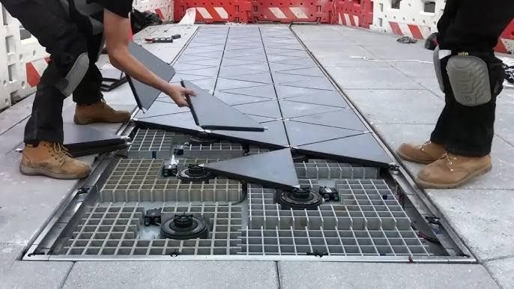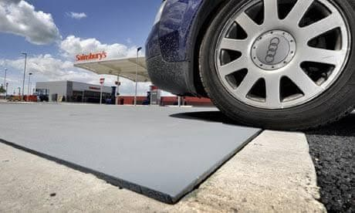

**#INNOVATIVE ASPECT:**

Devices like piezoelectric materials and electromagnetic harvesters convert vibrations, motion, or pressure into electricity. Piezoelectrics harness mechanical stress, while electromagnetic systems utilize a magnet moving through a coil. Harvested energy is stored in compact solutions like supercapacitors for quick use or batteries for long-term storage, enabling efficient energy capture and reuse.

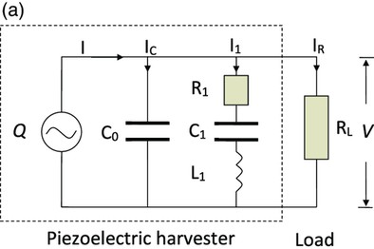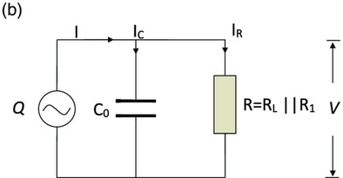

#### #POLICIES FOR IMPLEMENTATION FOR BOTH IDEAS:

1. Set clear standards for kinetic plates, subsidies and tax breaks to make installation more affordable and maintenance should be on regular basis.
2. Reference or collaboration with foreign companies like  [PAVEGEN](https://www.pavegen.com/) for its implementation.
3. Charging stations should collab with mass aggregators of public like parking spaces, dhabas, petrol pump reducing the search of land which will boom their business as well.

#### #RESEARCH AND REFERENCES

* Piezoelectric materials and circuit

diagrams-[https://onlinelibrary.wiley.com/doi/full/10.1002/sstr.202100128#:~:text=Piezoelectric](https://onlinelibrary.wiley.com/doi/full/10.1002/sstr.202100128#%3A~%3Atext%3DPiezoelectric%2520energy%2520harvester%2520is%2520the%2Cinto%2520the%2520usable%2520electrical%2520energy)

[%20energy%20harvester%20is%20the,into%20the%20usable%20electrical%20energy](https://onlinelibrary.wiley.com/doi/full/10.1002/sstr.202100128#%3A~%3Atext%3DPiezoelectric%2520energy%2520harvester%2520is%2520the%2Cinto%2520the%2520usable%2520electrical%2520energy)

* PAVEGEN reference - <https://www.pavegen.com/>